Game success prediction

Team members:

Sayed ashraf

Tarik zeyad

Mina lion

Ghaly Mansour

Featear selection using correlation heat map

Drop unneadded coulmns

Drop empty cells in features size, in-app-purchses, sub-title, ID

Encode in-app-purchses, sub-title using lable encoder to transform them from strings

To numbers

Globle corolation

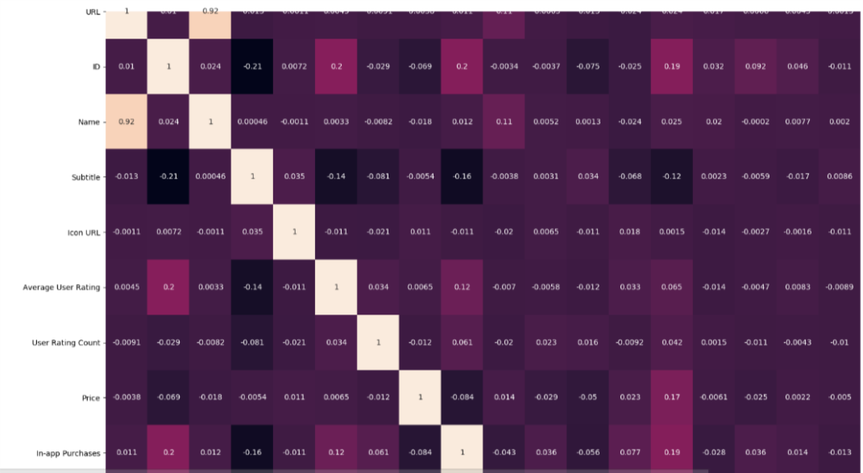

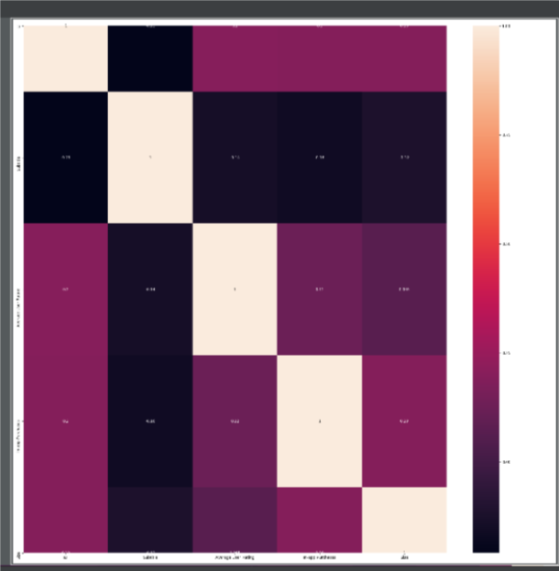

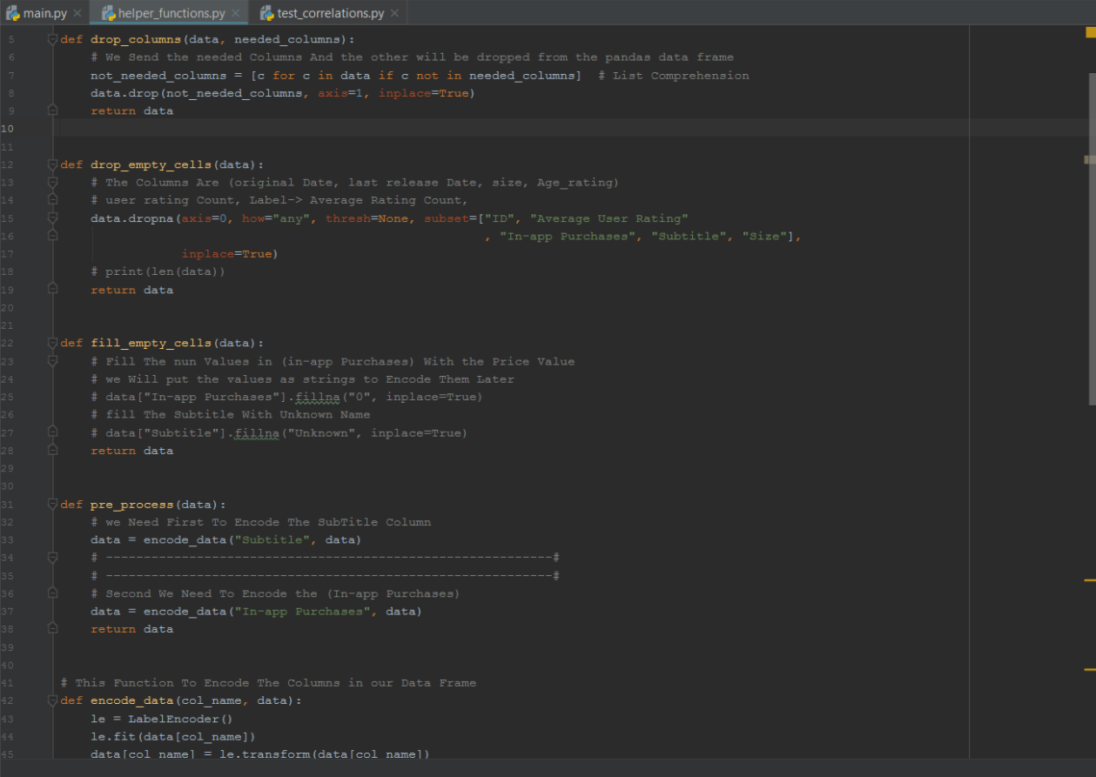

then we used two modules multi-features-regression and polynomial-regression

multi-features using the linear features

polynomial-regression using features to the power of the degree which the user will input

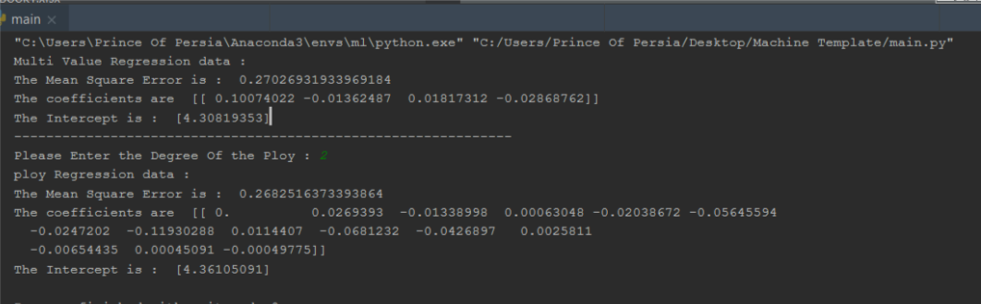polynomial-regression with higher degree more than 2 will cause over-fitting

According to the corelations we drop all columns except size, sub-title, in-app-purches, ID and lable that is in average user ratting